Olly Powell (19/12/2025)
Task A — Unnormalised Table (4 Marks)
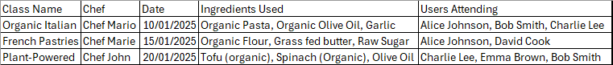
Why This Design Causes Problems
- Data Redundancy
  - Chef names, ingredient lists, and user names are repeated across multiple rows. For example, if “Organic Olive Oil” is used in three classes, it appears three times.
  - This wastes storage and makes the database inefficient.
- Update Anomalies
  - If a chef changes their name or bio, you must update every row where that chef appears. Missing one update leads to inconsistent data.
  - Similarly, if an ingredient name changes (e.g., “Olive Oil” → “Extra Virgin Olive Oil”), you must update multiple rows manually.
- Insert Anomalies
  - You cannot add a new ingredient or user unless it is tied to a class. For example, if Gourmet Delights adds “Organic Quinoa” to its catalogue, you cannot store it without creating a dummy class.
- Delete Anomalies
  - If you delete a class record (e.g., a cancelled class), you might lose all information about the chef, ingredients, and attendees linked to that class—even if they are still relevant for other classes.
- Poor Query Performance
  - Searching for all classes that use “Organic Olive Oil” requires scanning through large text fields with comma-separated lists.
  - Reporting (e.g., “Which ingredient is most used?”) becomes complex and error prone.
- No Data Integrity
  - There are no constraints to ensure that a user or ingredient exists only once. Duplicate names can occur easily, leading to confusion.

Task B — Normalise the Data into at Least Three Tables (6 Marks)
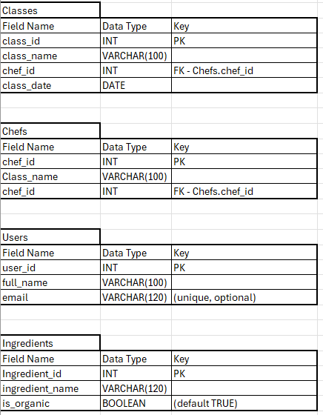
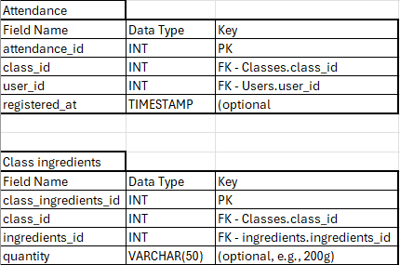
Task C — ERD (4 Marks)
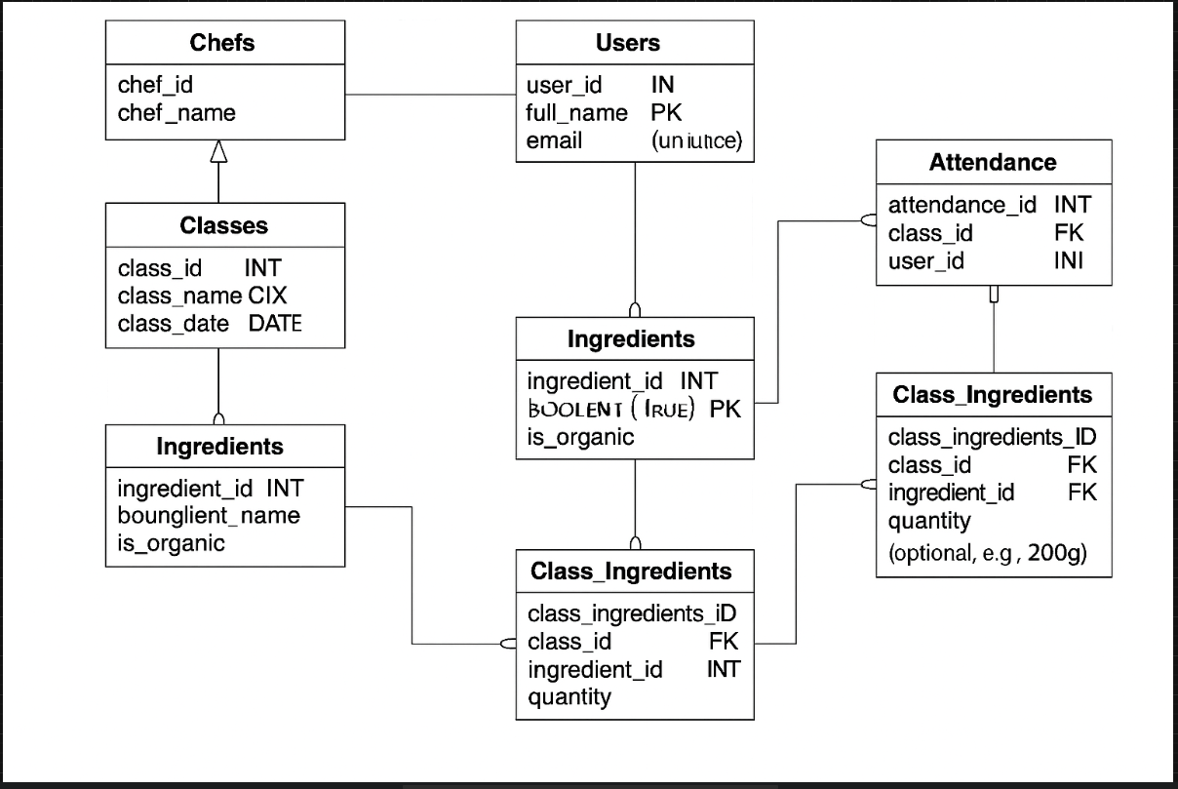Task D — Explain Normalisation (3 Marks)
Normalisation organises data into related tables to reduce redundancy and prevent anomalies (update, insert, delete). For Gourmet Delights (an organic food store running classes), normalisation ensures chef details, ingredients, and attendance aren’t duplicated across rows, making updates reliable and reducing the risk of inconsistent data. It also improves query performance and reporting (e.g., “Which organic ingredients are most used across classes?”). As explained in Craig’n’Dave’s normalisation material, reaching Third Normal Form (3NF) removes transitive dependencies and creates a clear, scalable structure suitable for business growth.
Task E — Craig’n’Dave Notes (3 Marks)
Revision Notes — OCR A Level SLR10 (Normalisation to 3NF):
- 1NF (First Normal Form):
  - Ensure atomic values (no lists in a single cell).
  - Remove repeating groups; each field holds one value.
  - Each record is uniquely identifiable (introduce primary keys).
- 2NF (Second Normal Form):
  - Be in 1NF.
  - Remove partial dependencies (every non-key attribute must depend on the entire key in a composite-key table).
- 3NF (Third Normal Form):
  - Be in 2NF.
  - Remove transitive dependencies (non-key attributes must depend only on the key, not on other non-key attributes).
- Benefits of Normalisation:
  - Reduced redundancy → smaller storage footprint and fewer inconsistencies.
  - Fewer anomalies → safer updates/inserts/deletes.
  - Clearer relationships → easier queries, reporting, and maintenance.
- Why 3NF is Efficient:
  - Strong balance between integrity and performance for operational databases.
  - Supports modular growth (add tables/features without disturbing core design).

Final Section — Use of AI and Web Sources
I used Microsoft Copilot to structure the assignment and generate examples for tables, relationships, and explanations tailored to Gourmet Delights being an organic food store that runs cooking classes. I referenced the Craig’n’Dave video on Normalisation to 3NF for the definitions of 1NF, 2NF, 3NF and the benefits of normalisation, which informed the revision notes and integrity-focused design.

